Project Design Phase-II
Data Flow Diagram & User Stories

Date | 02 October 2026
Team ID | SWTID-2026-8115
Project Name
Maximum Marks | 4 Marks

Data Flow Diagrams:
For Auto Ticket Classification using Flow Designer, the data flow diagram shows how an employee submits a support ticket, how Flow Designer evaluates configured classification conditions, and how the result is stored and routed for service desk review.
Example: DFD Level 0 (Industry Standard)
Project flow: ticket creation and automatic classification
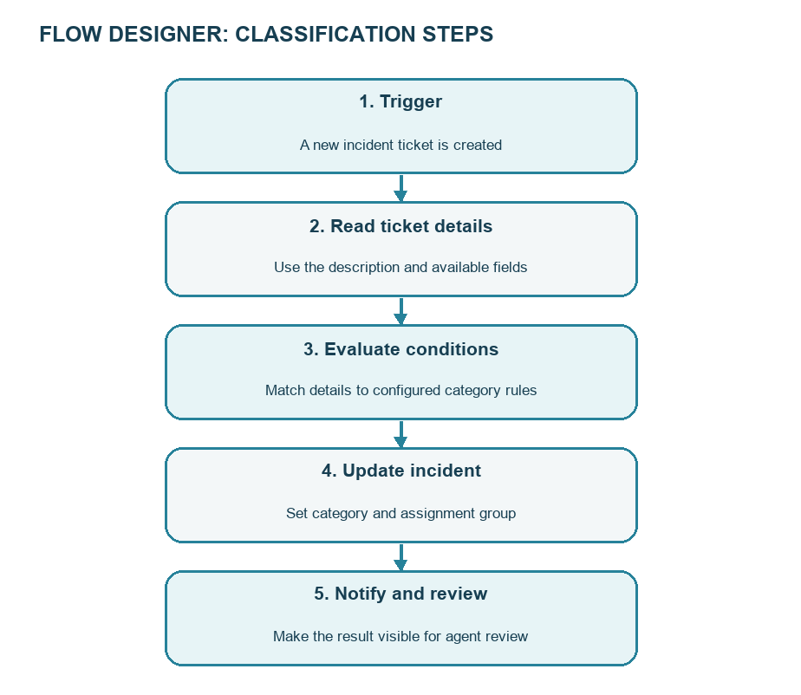

User Stories
The user stories below describe the employee, service desk agent, and administrator tasks for Auto Ticket Classification using Flow Designer.
User Type | Functional Requirement (Epic) | User Story Number | User Story / Task | Acceptance criteria | Priority | Release
Employee | Ticket submission | USN-1 | As an employee, I can submit an IT issue with a clear description so support can review it. | A ticket is saved with a unique number and required details. | High | Sprint-1
Employee | Ticket status | USN-2 | As an employee, I can view the ticket status so I know that my request was received. | The saved ticket and current status are visible to the requester. | High | Sprint-1
Service Desk Agent | Automatic classification | USN-3 | As a service desk agent, I want new tickets checked against configured rules so common issues are categorized consistently. | A matching rule sets the intended category and subcategory. | High | Sprint-1
Service Desk Agent | Automatic assignment | USN-4 | As a service desk agent, I want a classified ticket assigned to the related support group so it reaches the right team. | The assignment group is set when a rule match is found. | High | Sprint-1
Service Desk Agent | Review exceptions | USN-5 | As a service desk agent, I can review tickets that do not match a rule so they are not left with an unreliable classification. | Unmatched tickets remain available for manual review. | High | Sprint-1
Service Desk Agent | Correct classification | USN-6 | As a service desk agent, I can correct a category or group when the automatic result is wrong. | Authorized agents can update the ticket fields. | High | Sprint-2
Administrator | Maintain rules | USN-7 | As an administrator, I can maintain the classification conditions so they reflect the support categories used by the team. | Authorized administrators can review and update the rules. | Medium | Sprint-2
Administrator | Flow monitoring | USN-8 | As an administrator, I can review flow outcomes so configuration issues can be identified. | Flow execution results can be checked using available platform records. | Medium | Sprint-2
Employee | Notification | USN-9 | As an employee, I receive an update when my ticket is classified and routed. | A notification or visible ticket update reflects the saved result. | Medium | Sprint-2
Service Desk Agent | Ticket queue | USN-10 | As a service desk agent, I can view assigned tickets so I can work on the requests for my group. | The agent can open tickets assigned to the group, subject to access. | High | Sprint-1
Administrator | Access control | USN-11 | As an administrator, I can limit ticket and rule access to authorized roles. | Access follows the platform role and access-control configuration. | High | Sprint-1
Administrator | Classification review | USN-12 | As an administrator, I can review corrected classifications to identify rules that need improvement. | Corrected tickets can be reviewed for future rule updates. | Low | Sprint-2

